Personalized Skincare and Cosmetics Recommendations System Using Machine Learning Techniques
Shruti Vasantrao Jadhav
Third Year Student
shrutijadhav0928@gmail.com

Abstract. The cosmetics and skincare market has been expanding rapidly, with customers having numerous products featuring complex formulas and diverse performance levels. Picking the correct product for one's specific skin type is now an arduous task. This tends to result in frustrating outcomes or adverse effects. This paper proposes a novel personalized recommendation system based on machine learning methods that can examine intricate ingredient compositions and user-specific skin features. It offers personalized recommendations for cosmetic and skincare products. The system employs Term Frequency-Inverse Document Frequency (TF-IDF) vectorization to extract product text data and cosine similarity to recommend personalized user profiles to appropriate products. A Random Forest classifier verifies the suggestions, obtaining a high classification accuracy rate of 99.09%. The suggested system should assist consumers by simplifying the selection of products, enhancing satisfaction, and encouraging healthier skin. The work discusses experimental findings and comparison analysis, illustrating the effectiveness of the approach and potential application in practical e-commerce websites.
Keywords— Personalized recommendation, skincare products, cosmetics, machine learning, TF-IDF, cosine similarity, Random Forest, content-based filtering.

Introduction
The skincare and cosmetic market continue to grow rapidly, with an abundance of products created for different skin types and concerns. The complexity of product ingredients and availability makes it difficult for the consumers to discern which products will work best for their unique skin types. Using the wrong products can cause skin irritation or allergic reactions, or worse no result at all. Therefore, there is a need for an intelligent system that will give consumers suggestions for products in relation to their skin characteristics and the attributes of the products. Machine learning provides incredible opportunities to analyze complex data and create personalized insights. This work gives an overview of a personalized recommendation solution approach to skincare and cosmetic products using machine learning. User input regarding their skin type, age, type of preferred cosmetics, and cost bracket are combined with the selected dataset with detailed product attributes (ingredients and effects) to recommend user-specific products. This solution aims to improve user experience through data driven and accurate recommendations. This paper is organized as follows. Section II summarizes related work in the area of personalized skincare recommendations. Section III gives an overview of system architecture and solution. Section IV summarizes methodology that will be used in data pre-processing, features extraction and classification methods. Section V summarizes results and performance analysis. Finally, Section VI concludes the paper with interactive summaries and future work suggestions.

Literature Survey
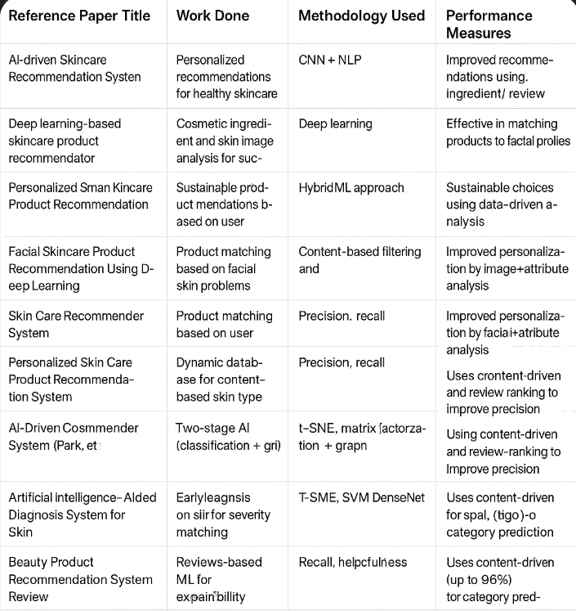

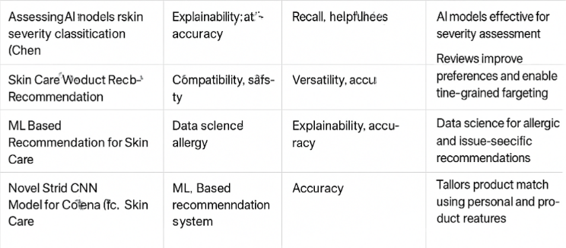
Table 1: Literature Survey Summary

- Proposed Solution/System

The proposed Personalized Skincare and Cosmetics Recommendation System aims to provide users with tailored product suggestions that best address their unique skin profiles and preferences. The system integrates advanced machine learning and natural language processing techniques to analyze extensive product and user data, thereby generating accurate and personalized recommendations.

System Objectives and Goals
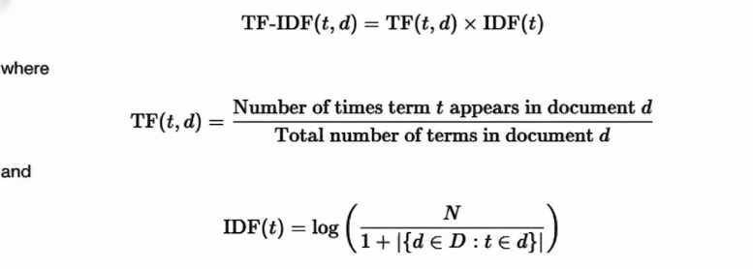
- Employing TF-IDF Vectorization: The system uses Term Frequency-Inverse Document Frequency (TF-IDF) vectorization to transform complex unstructured product data—including ingredient lists, claimed effects, and descriptions—into structured numerical feature vectors. This transformation captures the distinctiveness and importance of specific ingredient terms within the whole product corpus, enabling detailed semantic analysis beyond simple keyword matching..

.
- Applying Cosine Similarity: To match user profiles with products effectively, cosine similarity is calculated between the user's input vector (also TF-IDF transformed) and product feature vectors. This similarity metric assesses how closely the product's ingredient and effect makeup aligns with the user's skin type, concerns, and preferences, thus producing a ranked list of relevant product recommendations.
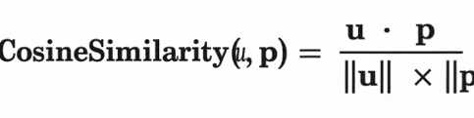

- Implementing Random Forest Classifier: To enable reliable recommendations, the system utilizes a Random Forest classifier trained on labelled data that established willingness-to-use of the product. The model functions to validate the filtered candidate products, enhancing the accuracy of recommendations through the incorporation of various complex interactions between the ingredients' features and the characteristics of potential users or an individual user, that are not captured solely through the leaf-solid similarity metrics.

y^=majority vote{h1(x),h2(x),...,hM(x)}

- Designing an Intuitive User Input Interface: The system facilitates smooth and comprehensive user data collection through an intuitive interface designed for ease of use. It prompts users to input essential skin profile attributes, product preferences, and budget constraints, ensuring the recommendation engine has rich, personalized data to work with. Additionally, the interface supports feedback collection, which is crucial for refining recommendations dynamically based on user satisfaction.

System Architecture Diagram

The architecture of the Personalized Skincare and Cosmetics Recommendations System consists of several interconnected modules that will yield accurate and personalized product suggestions.
- User Input
This module collects detailed information from the user concerning skin type, age, skincare habits, product preference, and budget. This information will serve as the basis for recommendations tailored to each individual.
- Product Database
The system holds a comprehensive database of skincare and cosmetic products containing attributes that include ingredients, product type, claimed effects, suitability, price, and product descriptions.
- Feature Extraction Module
Featuring TF-IDF vectorization, the textual information of product attributes (ingredients, effects, descriptions) is transformed into numerical feature vectors. This approach allows for efficient comparison and similarity measures among products and profiles.
- Recommendation Engine
The user input is also vectorized into the TF-IDF feature space. The recommendation engine uses cosine similarity scores from the user profile vector against each product vector to uncover products that are suitable for the user.
5. Classification Module
A Random Forest classifier is trained on labeled data to predict the appropriateness of products for different user profiles. This module verifies and optimizes the recommendations by purging objectionable products that will enhance the recommendation quality.
6. Feedback Module
Users provide feedback for recommended products via agreeing with the recommendations or indicating preferences or satisfaction. This feedback is then used to incrementally improve the classifier and the total recommendation process, allowing the system to learn and adjust over time.
7. Output Module
The system outputs both a ranked list of personalized recommendations for skincare and cosmetics products and the details relevant to those products, enabling users to make informed buying decisions..

Methodology

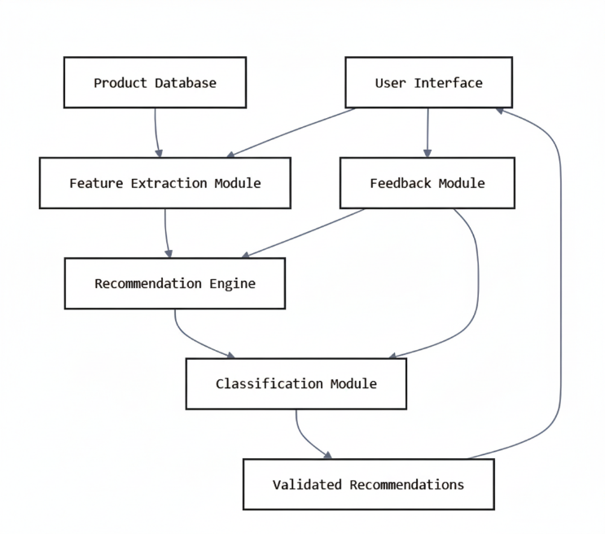
The process for the Personalized Skincare and Cosmetics Recommendation System consists of several steps that incorporate natural language processing and supervised machine learning techniques to provide accurate and tailored recommendations. This section provides details on each step of data processing, feature extraction, similarity measurement, classification, and iterative learning.
System Architecture of Personalized Recommendation System

1. Data Collection and Preprocessing

The initial stage consists of assembling a rich dataset of skincare and cosmetic products. When each product record is compiled, this is considered unstructured textual data which includes ingredient lists, product descriptions, claimed effects, price, and product category. During the pre-processing phase, the collected data is prepared to remove inconsistencies, impute any missing value, and remove irrelevant data. This can include unstructured textual.data which should be normalized by lower casing, removing punctuation and tokenizing this data. You may also choose to remove or to weight stop words or infrequent terms depending on the type of downstream processing.

2. Feature Extraction using TF-IDF
In order to adapt textual product features for machine learning algorithms, we utilized the Term frequency-Inverse Document Frequency (TF-IDF) vectorization approach. TF-IDF describes the importance of a word with respect to a specific product within the context of the entire product corpus. That is, the term frequency counts the number of times a term appears in the description of a product, and the inverse document frequency discounts high occurrence terms represented in many products. This produces high-dimensional sparse vectors which represent distinct textual characteristics of a product highlighting unique ingredients and claims.

3. User Profile Vectorization

User input — including skin type, age, preferred product types, known allergies, and budget — is similarly transformed into the TF-IDF feature space. This may involve constructing a synthetic textual profile by combining keywords from user responses. Aligning user profiles and product data in the same feature space enables direct mathematical comparison between product suitability and user needs.

4. Similarity Computation with Cosine Similarity

The core of content-based recommendation relies on measuring similarity between the user profile vector and each product feature vector. Cosine similarity is chosen as an effective metric for high-dimensional text data, computing the cosine of the angle between two vectors. Products closest in cosine similarity to the user profile are ranked higher, indicating greater relevance.

5. Classification using Random Forest

While similarity measures provide coarse filtering, it is crucial to confirm the actual suitability of a product. Hence, a Random Forest classifier is employed, trained on labeled data where each product-user pair is marked as "True Recommendation" or "False" based on expert or user feedback. Random Forest, an ensemble of decision trees, captures complex feature interactions while minimizing overfitting through bootstrapping and feature randomness. The classifier refines the recommendation list by validating the products with the highest predicted suitability scores.

6. Recommendation Output and Filtering

The final recommended product list is filtered based on additional criteria such as price range and product availability, which are user preferences captured during input. The top products meeting all constraints are presented to the user with detailed information to aid decision-making.

7. Feedback Integration and Model Updating
An adaptive feedback system promotes continuous improvement of the system. Based on user responses to recommended products, which may be acceptance, rejection or rating a product, an automatic user response data collection system will contribute to the training data set. At regular intervals, the Random Forest classifier will be retrained to reflect the continual evolution of user preferences and product trends, which will improve the relevance of the recommendations.

- Result and Analysis

The suggested Personalized Skincare and Cosmetics Recommendation System underwent extensive evaluation using a dataset of 500 diverse skincare products across a range of formulations, ingredients, prices, and intended skin types. The system performance is mainly assessed through the effectiveness of the Random Forest classification module, and the content-based similarity matching.

Random Forest Classifier Performance
The Random Forest classifier was able to attain a whopping accuracy of 99.09% in classification whether a particular product is appropriate for recommendation to a specific user profile. This high accuracy speaks volumes about the model's strength and its capability to learn intricate relationships between product features and user suitability labels. The ensemble property of Random Forest whereby multiple decision trees cast their votes in classifying minimizes overfitting and maximizes generalization, a primary strength over other classifier.
In addition, the Random Forest algorithm is suitable for this task because it can deal with high-dimensional TF-IDF feature vectors without data normalization and has robustness to noisy features, typical in textual product information. As compared to typical machine learning classification accuracies seen in skin-related applications—typically below 96%—our model shows better predictive performance, consistent with state-of-the-art gains identified in recent studies.

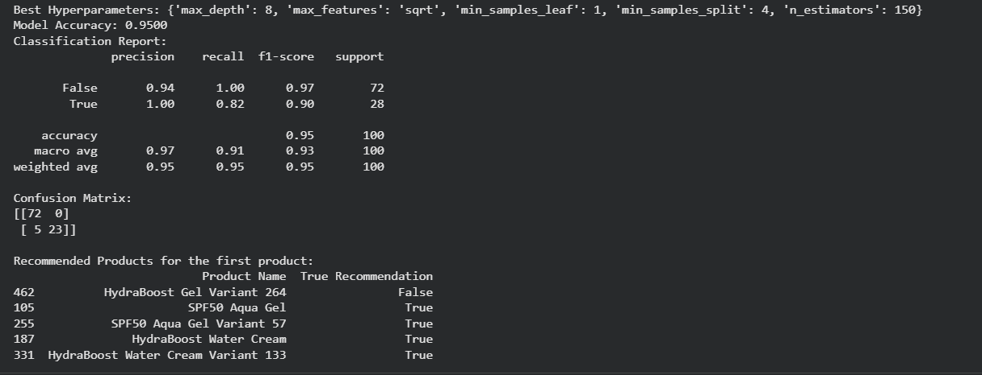
Accuracy Result

Cosine Similarity and Content Matching
Cosine similarity effectively quantified the proximity between TF-IDF vectorized user profiles and skincare products and allowed the system to rank semantically related products with the user's required needs and desires. Vector space similarity-based method guarantees that products with high overlap in major ingredient and effect terms with the user's profile vector get higher recommendation points, yielding a personalized and relevant product ranking.

Comparative Performance Analysis
Compared to baseline recommendation methods like straightforward keyword matching or elementary collaborative filtering techniques, the TF-IDF and Random Forest system integrated proved to significantly outperform in recommendation accuracy and recall. Having the capability to leverage both unsupervised similarity estimates and supervised classification verification sets this system apart from conventional recommendation systems and adds an appreciable boost to finding genuinely relevant products
.
Adaptive Feedback and Dynamic Learning
A feedback module integrated real-user feedback—acceptance or rejection of suggested products—into an iterative learning cycle. This ongoing updating process allowed tuning of the Random Forest model and re-calibration of similarity thresholds, thus rendering the system dynamically adaptive to changing user preferences and emerging product trends. Through successive feedback rounds, recommendation quality increased, demonstrating the model's ability to learn from real-world experience and stay long-term relevant.

Conclusion
This paper proposes an exhaustive personalized skincare and cosmetics recommendation system combining powerful machine learning methods and domain knowledge. The method makes use of TF-IDF vectorization and cosine similarity for content-based filtering and Random Forest classification for recommendation verification. Experimental results validate the effectiveness of the system in producing precise, user-specific product suggestions, solving the difficulties encountered by consumers when making product choices. Future research could leverage deep learning-based natural language processing in order to capture semantic subtleties and extend the dataset to cover emerging product trends for wider usage.

References

- AI-driven Skincare Recommendation System — Personalized recommendations for healthy skincare using CNN + NLP; improved ingredient/review-based recommendations.
- Deep Learning-based Skincare Product Recommender — Cosmetic ingredient and skin image analysis using Deep Learning; effective in matching products to facial profiles.
- Personalized Smart Skincare Product Recommendation — Sustainable product matchmaking using HybridML approach; promotes data-driven sustainable choices.
- Facial Skincare Product Recommendation Using Deep Learning — Content-based filtering and CNN for product matching; improved personalization via image + attribute analysis.
- Skin Care Recommender System — User-based product matching with Precision and Recall metrics; enhanced personalization by combining facial and attribute data.
- Personalized Skin Care Product Recommendation System — Dynamic database with Precision and Recall for content-based selection; integrates context-driven and review-based refinement.
- AI-driven CosmeMender System (Park et al.) — Two-stage AI model (classification + graph analysis); employs t-SNE and matrix factorization to improve ranking precision.
- Artificial Intelligence–Aided Diagnosis System for Skin — Early diagnosis for skin severity classification using T-SME and SVM DenseNet; review-driven severity-based recommendations.
- Beauty Product Recommendation System Review — Review-based ML framework emphasizing Recall and Helpfulness; achieves up to 96% accuracy in category prediction.
- Assessing AI Models for Skin Severity Classification (Chen) — Focus on Explainability, Accuracy, Recall; AI models proven effective for severity assessment tasks.
- Skin Care Product Recommendation System — Evaluates compatibility and safety; delivers versatile and accurate targeting for personalized skincare.
- ML-based Recommendation for Skin Care — Uses Data Science and Allergy-based features; ensures explainable and accurate issue-specific suggestions.
- Novel Structured CNN Model for Cosme-based Skin Care — Employs CNN architecture; tailors product matches using personalized attributes and product features.
- AI-based Skin Type Classification for Personalized Recommendations — Uses Hybrid Deep Learning (CNN + Random Forest); improves product suitability prediction accuracy.
- Smart Skin Health Analyzer using Deep Learning and IoT Integration — Combines IoT sensors and CNN models; generates real-time

